Driving processes of daily streamflow trends in the central Norwegian mountains

Amalie Skålevåg¹, Klaus Vormoor¹
¹ Institute of Environmental Science and Geography, University of Potsdam, Potsdam, Germany

To be submitted to Hydrological Processes
https://onlinelibrary.wiley.com/journal/10991085

30. Jan. 2020

Color coding in this document:
black: more or less finished, subject to minor edits
blue: needs to be edited or revised
red: additional information or notes to be removed before submitting

TAKE HOME MESSAGE:
- Examining trends in streamflow, rainfall, snowmelt and temperature reveals the (main) driving processes behind changes in streamflow
- The high-resolution trend analysis allows for in-depth seasonal-specific insights into the hydrological response of catchments with different hydrological regimes to changes in the hydro-meteorological drivers.
- Increasing (decreasing) contributions of rainfall (snowmelt) to streamflow generally agree with prior expectations. The trends, however, show differences in magnitude and timing, depending on the geographical location (Vestlandet vs. Østlandet) and altitude.
- The seasonal multiple regression approach suggests that daily streamflow changes can be explained best by adding temperature as an additional predictor to snowmelt and rainfall, which may indicate the changing relevance of evapotranspiration particularly during summer.

Preliminary abstract
Max. 300 words
Context (1 sentence)
Mountainous and Nordic regions are experiencing more rapid temperature increases compared to regions at lower altitudes and latitudes, which will impact the hydrology in these regions.
Methods and data (no more than 1/3, i.e 100 words)
For Norway, there is increasing evidence for gradually increasing temperatures and recent changes in the intensity and frequency of precipitation as well as in the number of days with snow cover. The most pronounced differences regarding their hydro-meteorological regime can be found between Western and Eastern Norway (Vestlandet vs. Østlandet). Most catchments in these regions are characterized by mixed snowmelt/rainfall regimes with streamflow peaks during spring (dominant in Østlandet) and autumn (dominant in Vestlandet).
We analysed daily-resolved streamflow trends for 112 catchments in Western and Eastern Norway for the period 1983-2012, and compared them with daily-resolved trends in the hydro-meteorological drivers. Additionally, the relative contribution of snowmelt and rainfall to daily streamflow for each catchment were estimated and trends therein identified. This process-orientated approach at high temporal resolution allows for a better identification of (in)consistencies with changes in the hydro-meteorological drivers than simple seasonal comparisons. Lastly, we aim to attribute observed changes in daily streamflow to the most dominant hydro-meteorological drivers by applying seasonal multiple-regressions.
Results (at least 1/3, i.e 100 words, includes THM, be quantitiative)
The major findings of this study are as follows:
- The high-resolution trend analysis allows for in-depth seasonal-specific insights into the hydrological response of catchments with different hydrological regimes to changes in the hydro-meteorological drivers.
- Increasing (decreasing) contributions of rainfall (snowmelt) to streamflow generally agree with prior expectations. The trends, however, show differences in magnitude and timing, depending on the geographical location (Vestlandet vs. Østlandet) and altitude.
- The seasonal multiple regression approach suggests that daily streamflow changes can be explained best by adding temperature as an additional predictor to snowmelt and rainfall, which may indicate the changing relevance of evapotranspiration particularly during summer.
Discussion/Outlook (1 sentence)
Further work should focus on including more drivers, e.g. groundwater or evapotranspiration, or attribution.

(8) Keywords: high-resolution trend analysis; streamflow trends; hydro-meteorological drivers; Sen’s slope estimator; hydrological change; Norway;

7500 word limit
The following sections are included as part of the word count: abstract; main text; and the acknowledgements. The following sections are excluded: title page, including author list and affiliations; bibliography; figure legends and supporting information.

Introduction
Context
General/global → Norway
“In Norway, temperatures have increased and there have been regional changes in precipitation and annual runoff, as well as increased winter and spring runoff and earlier snowmelt (Wilson et al., 2010). A continued increase in temperature and precipitation (except for the summer season) is predicted (Hanssen- Bauer et al., 2009). More frequent episodes of extreme rainfall are also anticipated. Changes in climate are expected to lead to changes in hydrology, with increasing annual runoff, and greater runoff in the autumn and winter and less during summer (Beldring et al., 2008).” (Fleig et al., 2013)
“The projections of future discharge from the individual basins show a general pattern; snowmelt floods will occur earlier and winter and autumn discharge will increase, while summer and spring discharge will decrease. These projections of future streamflow result from changes in both temperature and precipitation, with temperature changes having a larger impact than pre- cipitation changes (Beldring et al., 2006).” (Beldring, Engen-Skaugen, Førland, & Roald, 2008)⁠
“Moderate changes in the annual streamflow are expected, with a decline in some basins for some scenarios. The increase is dependent on the spatial distribution of the pressure fields as modelled by the two global climate models. Significant changes in the seasonal distribution of streamflow are expected; increase everywhere in the winter, increase in mountainous basins in southern Norway and in basins in central and northern Norway in the spring, a moderate decline in coastal basins in southern Norway and a moderate increase in basins in south-eastern Norway in the spring. Decrease will occur everywhere in the summer, while autumn streamflow will increase in every basin.” (Beldring, Roald, Engen-Skaugen, & Førland, 2006)⁠
“Norway has a long and rugged coastline, spans 13 degrees of latitude, and has large seasonal and regional variations in climate and hydrology. A good regional coverage of hydrological stations is needed to capture this variability and also for the detection of future changes. Several studies have shown that climate predictions vary considerably between different parts of the country (Hanssen-Bauer et al., 2009)” (Fleig et al., 2013)⁠
State the issue (related to THM)
Streamflow rates are the result of several interlocking catchment scale processes as well as variation in hydro-meteorological variables determined by prevailing climate patterns and variability. (Pretty sure there is a source for this in MSc Diss). Catchment properties can be altered by human activities such as land use change, or by hydrological alterations. Therefore, the detection and attribution of climate change influences in streamflow changes can be difficult. The first step in attributing streamflow changes/trends to climate change is to identify which hydrological processes/variables are driving the change. To this end we analysed streamflow trends in 112 Norwegian catchments, spanning an elevation range of about 2500 m and representing various hydrological regimes, in conjunction with rainfall, snowmelt, and temperature trends, to identify the main processes driving streamflow change.
“How will cold region runoff and groundwater change in a warmer climate (e.g. with glacier melt and permafrost thaw)?” (Blöschl et al., 2019)⁠
“In order to predict and prepare for changes in hydrological characteristics under a changing climate, good knowledge about observed hydrological changes and their causes is necessary. This includes not only improved knowledge about changes in the mean hydrological characteristics, but also changes in annual and seasonal variability as well as in the frequency and magnitude of extreme events.” (Fleig et al., 2013)⁠
“As hydrological variability is driven by climate and modified by catchment characteristics and changes in land cover, it is difficult to attribute hydrological change to the different driving forces.” (Fleig et al., 2013)⁠
Several authors have suggested that examining seasonal and sub-seasonal trends may be more appropriate than annual trends, when it comes to hydrological change. Indeed, when both an annual and high-resolution trend analysis is performed, it is revealed that there may be significant seasonal change where no significant annual change is detected (Skålevåg, 2019)⁠. Additionally, seasonal/monthly trends could help explain the underlying causes of any detected annual changes (Stahl et al., 2010)⁠.
Alterations in streamflow (non-antropomorphic) detected, but what is driving the change?

Lit.review (Summarise findings in the literature on the science question, 2-3 pages, organised by science questions similarly to discussion later)
Global streamflow trends
European/Nordic streamflow trends
Drivers of streamflow trends (focus on areas where snowmelt plays an important role)
Attributing streamflow trends to drivers, data- vs. model-based
Value of examining annual vs. seasonal/monthly/high-res trends
Trends in indeces, e.g. center of volume, timing of certain events, comparing mean hydrographs for different periods etc.

Purpose (identical with science question, make it explicit)
Our study aims at a better understanding drivers of streamflow trends in central Norway by analysing daily streamflow records in conjuction with daily rainfall, snowmelt and temperature data using a high-resolution trend analysis approach. Our focus is on identifying the dominant processes driving streamflow change, and …
“Precipitation, snow accumulation and timing of snowmelt are the main factors determining the hydrological regime in Norwegian catchments (Hanssen-Bauer et al., 2015).” (Skålevåg, 2019)⁠. Therefore, we hypothesise that examining daily trends in snowmelt and rainfall should to a large extent explain streamflow trends.
The high-resolution trend analysis approach was developed for analysing streamflow, snow … changes (C. Kormann, Francke, & Bronstert, 2014; C. Kormann, Francke, Renner, & Bronstert, 2015; Christoph Kormann, Bronstert, Francke, Recknagel, & Graeff, 2016)⁠, and has also been used to asses elevation-dependent temperature trends and their underlying mechanisms (Rottler, Kormann, Francke, & Bronstert, 2019)⁠, but has yet to be applied to a region other than the Alps.
To this end, daily streamflow records from 112 Norwegian catchments were analysed, in conjunction with daily rainfall, snowmelt and temperature data, extracted from a nation wide 1x1km dataset interpolated from meteorological station measurements. Using a high-resolution trend analysis approach.
The aim of this paper is .. / The objective of the paper is .. / The main research questions we want to address in this paper are:
- Analyse the trends in streamflow, and hydro-meteorological drivers
- Assess to what extent trends in the hydro-meteorological drivers can explain streamflow trends

Study area and data
(local details of your data, including study area, geographical location, number of stations, record length)

Hydro-climatological and runoff conditions
Needs some sort of introductory sentence.
Due to early development of hydropower, Norway has a long tradtition of measuring and monitoring streamflow. Therefore, has some very long streamflow records, also many records. The NVE manages an extensive hydrometric observation network, with some …. gauging stations. Many of these are from catchments which are heavily impacted by athropogenic influences.
The study area spans a geographical range of 5-12°E and 59-63°N, and an altitudinal range of 0-2500 m.a.s.l. The area has been divided into two regions, Vestlandet and Østlandet, which lie west and east of the central Norwegian mountains respectively, and correspond to two of the six Norwegian runoff regions defined by NVE, which are based on watershed and administrative boundaries.
The typical flow regime in Norway consists of a winter low flow period, a clearly defined snowmelt flood in spring, a summer low flow period, and the occasional autumn flood due to precipitation as rain (Gottschalk, Jensen, Lundquist, Solantie, & Tollan, 1979)⁠. However, the hydrological condisiton in Norway varies greatly. (Spatial, inter-annual variability).
Vestlandet has generally high precipitation rates, with some areas having a mean annual precipitation as high as 3500-4000 mm, while in some valleys in Østlandet, in the rain shadow of the Scandinavian Mountains, mean annual precipitation is around 300-400 mm (Hanssen-Bauer et al., 2015)⁠. Østlandet has a more continental climate with cold and dry winters, the highest summer temperatures and the bulk of the annual precipitation falls in summer. In Vestlandet the bulk of the precipitation falls in autumn and winter, and the winters are mild and humid. Lower-altitude catchments in Vestlandet (coastal) are generally dominated by precipitation, and snowmelt plays a smaller role in the hydrological regime. Vestlandet generally has smaller catchments than Østlandet, in addition to a steeper topography.

Streamflow records
Daily streamflow records from 112 gauging stations belonging to the hydrometric observation network of the Norwegian Water Resources and Energy Directorate (NVE) formed the basis of the trend analysis. The majority of these stations are part of the Norwegian Hydrological Reference Network (HRN) compiled by NVE, and have been assessed as suitable for study of the effects of climate variability and change on the hydrology in Norway (Fleig et al., 2013)⁠. The catchments were selected according to the criteria set out by Whitfield et al. (2012), meaning they are pristine or near-natural, with less than 10% affected by basin development and absent of significant hydrological alterations. The streamflow data from some of these stations have previously been used in hydrological trend studies both of Europe, the Nordic countries and Norway (Hisdal, Stahl, Tallaksen, & Demuth, 2001; Stahl et al., 2010; Vormoor, Lawrence, Schlichting, Wilson, & Wong, 2016)⁠. Further streamflow records were added to those of the HRN, whose catchments are more affected by land use, but still unaffected by major hydrological alterations.
The study period from 1983-2012 was chosen to ensure the best spatial and altitudinal coverage. (The most recent records availiable to us were from 2014.) The data quality of the catchments belonging to the Norwegian HRN have already been assessed. We further enured that only streamflow records from catchments with less than 10% days missing in the chosen period were included in the analysis.
Some of the catchments are sub-catchments of each other or the same larger catchment, which can be identified by the first part of the station/catchment number (Tab. 1).

Hydro-meteorological data (Rainfall, snowmelt and temperature)
Daily data for the hydro-meteorological drivers, rainfall, snowmelt and temperature, were extracted for each catchment from a daily 1 x 1 km² gridded dataset covering the entirity of Norway, which contains data for a range of hydro-meteorological variables from 01.09.1957 to the present and is available to the public at www.seNorge.no. The dataset has been updated several times since its launch in 2006 (Engeset, 2016)⁠.
Precipitation and temperature data in the seNorge dataset (version 1.1.1) is interpolated from meteorological stations measurements, using triangulation and de-trended kriging respectively (see Mohr & Tveito, 2008)⁠. Precipitation is exposure and altitude corrected.
During large parts of the year precipitation accumulates as snow instead of contributing runoff, which complicates the analysis of daily trends. Therefore, we only consider rainfall in this study, which was defined as precipitation on days with temperatures above 0.5 °C. To complement the rainfall data we use daily snowmelt grids, which is modelled with the seNorge snow model (version 1.1.1) (Saloranta, 2014)⁠. The model uses daily temperature and precipitation grids as input, and simulates various variables including snow depth, snow water equivalents, and snowmelt, employing a simple degree-day method with an additional term related to the seasonal and zonal variation in incoming short-wave radiation (see Saloranta, 2014)⁠.
Daily temperature, rainfall and snowmelt time series were extracted from the seNorge grids for each of the 112 catchments by taking the mean.
“We acknowledge that the attribution of snowmelt generated flood events, based on modelled grid-based data, is not without limitations. Snowmelt observations are rare and represent point measures, making the gridded maps based on simulated data the best available data product for areal snowmelt in Norway. In the application of the data presented, the simulated snow data are only used for the classification of flood events and do not impact the observed peak discharge series used for the trend analyses.” (Vormoor et al., 2016)
The fraction of streamflow contributed by snowmelt or rainfall were estimated from the extracted rainfall and snowmelt time series (see Methods).
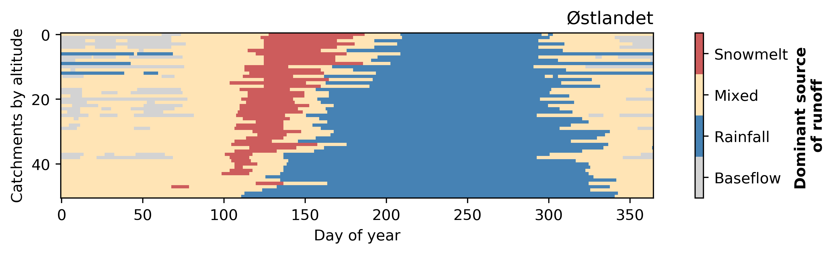
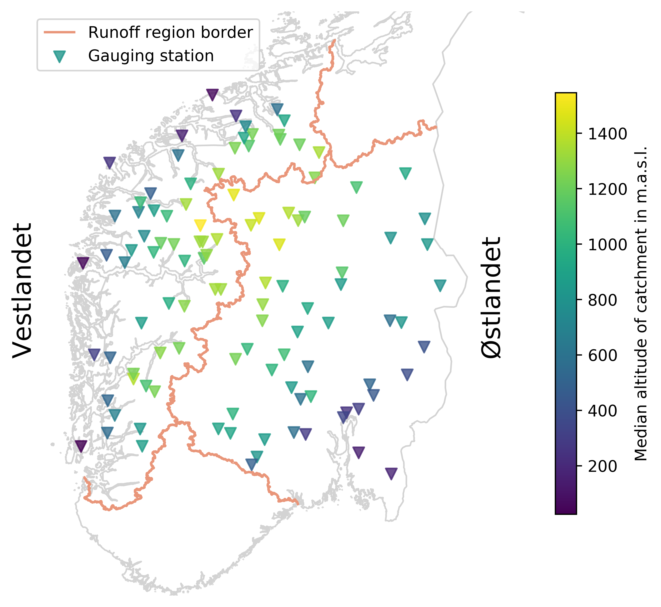
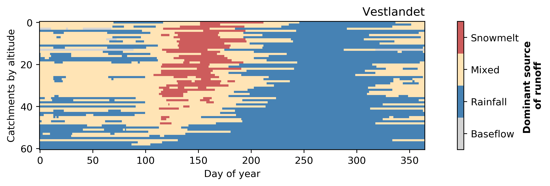
Figure 1: Catchment locations, mean contribution to runoff (describe the data behind the plot)
Table 1: list of catchments with stnr,altitude, indicating if they are part of the Norwegian HRN or not.

Methods
(avoid general statements but give the details of what you actually did)

Contribution to streamflow
A simple procedure was used to estimate the fraction of streamflow contributed by rainfall or snowmelt, using the catchment specific parameter “normal flood duration” (NFD). “NFD is composed of the concentration and the recession times of a maximum flood event within a specific catchment” (Vormoor et al., 2016)⁠. The NDF was either estimated either empirically or modelled depending on the catchment. For details see Vormoor et al. (2016)⁠.
The runoff C contributed by X, i.e. either snowmelt or rainfall, at time t is defined as
(Eq. 1)
C describes the amout of runoff that variable X could theoretically contribute to streamflow at any given day (t).
The fraction f of streamflow contributed by either snowmelt or rainfall is defined as
and (Eq. 2)
During some periods in winter, neither snowmelt nor rainfall were contributing to runoff. It is assumed that baseflow is the dominant source of streamflow in these periods.

High-resolution trend analysis
The daily trend analysis procedure is based on Kormann et al. (2014; 2015)⁠. The daily trend analysis procedure was applied to the streamflow (Q), rainfall (RF), rainfall contribution (RFC), snowmelt (SM), snowmelt contribution (SMC), and temperature (T) time series.
MA-filtering
Firstly, A moving average filter is applied to the original time series.
The MA filter is applied due to the high variability of the DOY time series, which impacts the MK test’s ability to detect trends. Kormann et al. (2014, 2015)⁠ used a 30dMA. However, in similar approaches 3dMA (Kim & Jain, 2010)⁠ and 5-day averages (Déry et al., 2009)⁠ have also been applied.
“A 5-day average was judged by Déry et al. (2009) to be sufficient to obtain similar hydrological responses from watersheds of varying sizes, in addition to minimising the effects of transient storms on precipitation fluctuations (Whitfield and Cannon, 2000).” (Skålevåg, 2019)⁠
We opted for a 10-day moving average filter because of previous research, which shows that the use of 30dMA may give an appearance of trends being more coherent and spread over a longer time window (Skålevåg, 2019)
DOY time series

Trend analysis
Secondly, from this modified time series 365 DOY time series are extracted and the trend magnitude estimated using the TS estimator.
The Thiel-Sen (TS) estimator (Sen, 1968; Theil, 1950)⁠ (also Sen’s slope estimator and Kendall-Theil robust line) is used to estimate trend magnitude. “the median of the slopes for each Xj − Xi pair”
The MK test was also applied to the DOY time series. The Mann-Kendall (MK) test (Kendall, 1975; Mann, 1945)⁠ is a non-parametric trend test for the detection of monotonic trends under the assumption that no autocorrelation is present in the time series to which it is applied (Chandler & Scott, 2011; Helsel & Hirsch, 1992)⁠.The test is widely applied in hydrology for the detection of significant trends (Burn et al., 2012)⁠.
Autocorrelation test (Ljung & Box, 1978)⁠ to test for significant lag-1-autocorrealtion.
Pre-whitening procedure after (Wang & Swail, 2001)⁠
(Eq. 3)
Field significance
Visualisation
Finally, the trend magnitude for each DOY time series is aggregated into a daily resolved yearly trend graph (Fig. 2).
Compiling the daily trend graphs for each catchment in a region were complied to display regional trends.

All data analysis was carried out using Python and trend module from USGS was used for the MK test and TS estimator. “Python 3.7 (Python Software Foundation, 2018) and python package trend (Hodson, 2018; available at https://github.com/USGS-python/trend) was used when computing the MK test and SS estimator” (Skålevåg, 2019)⁠
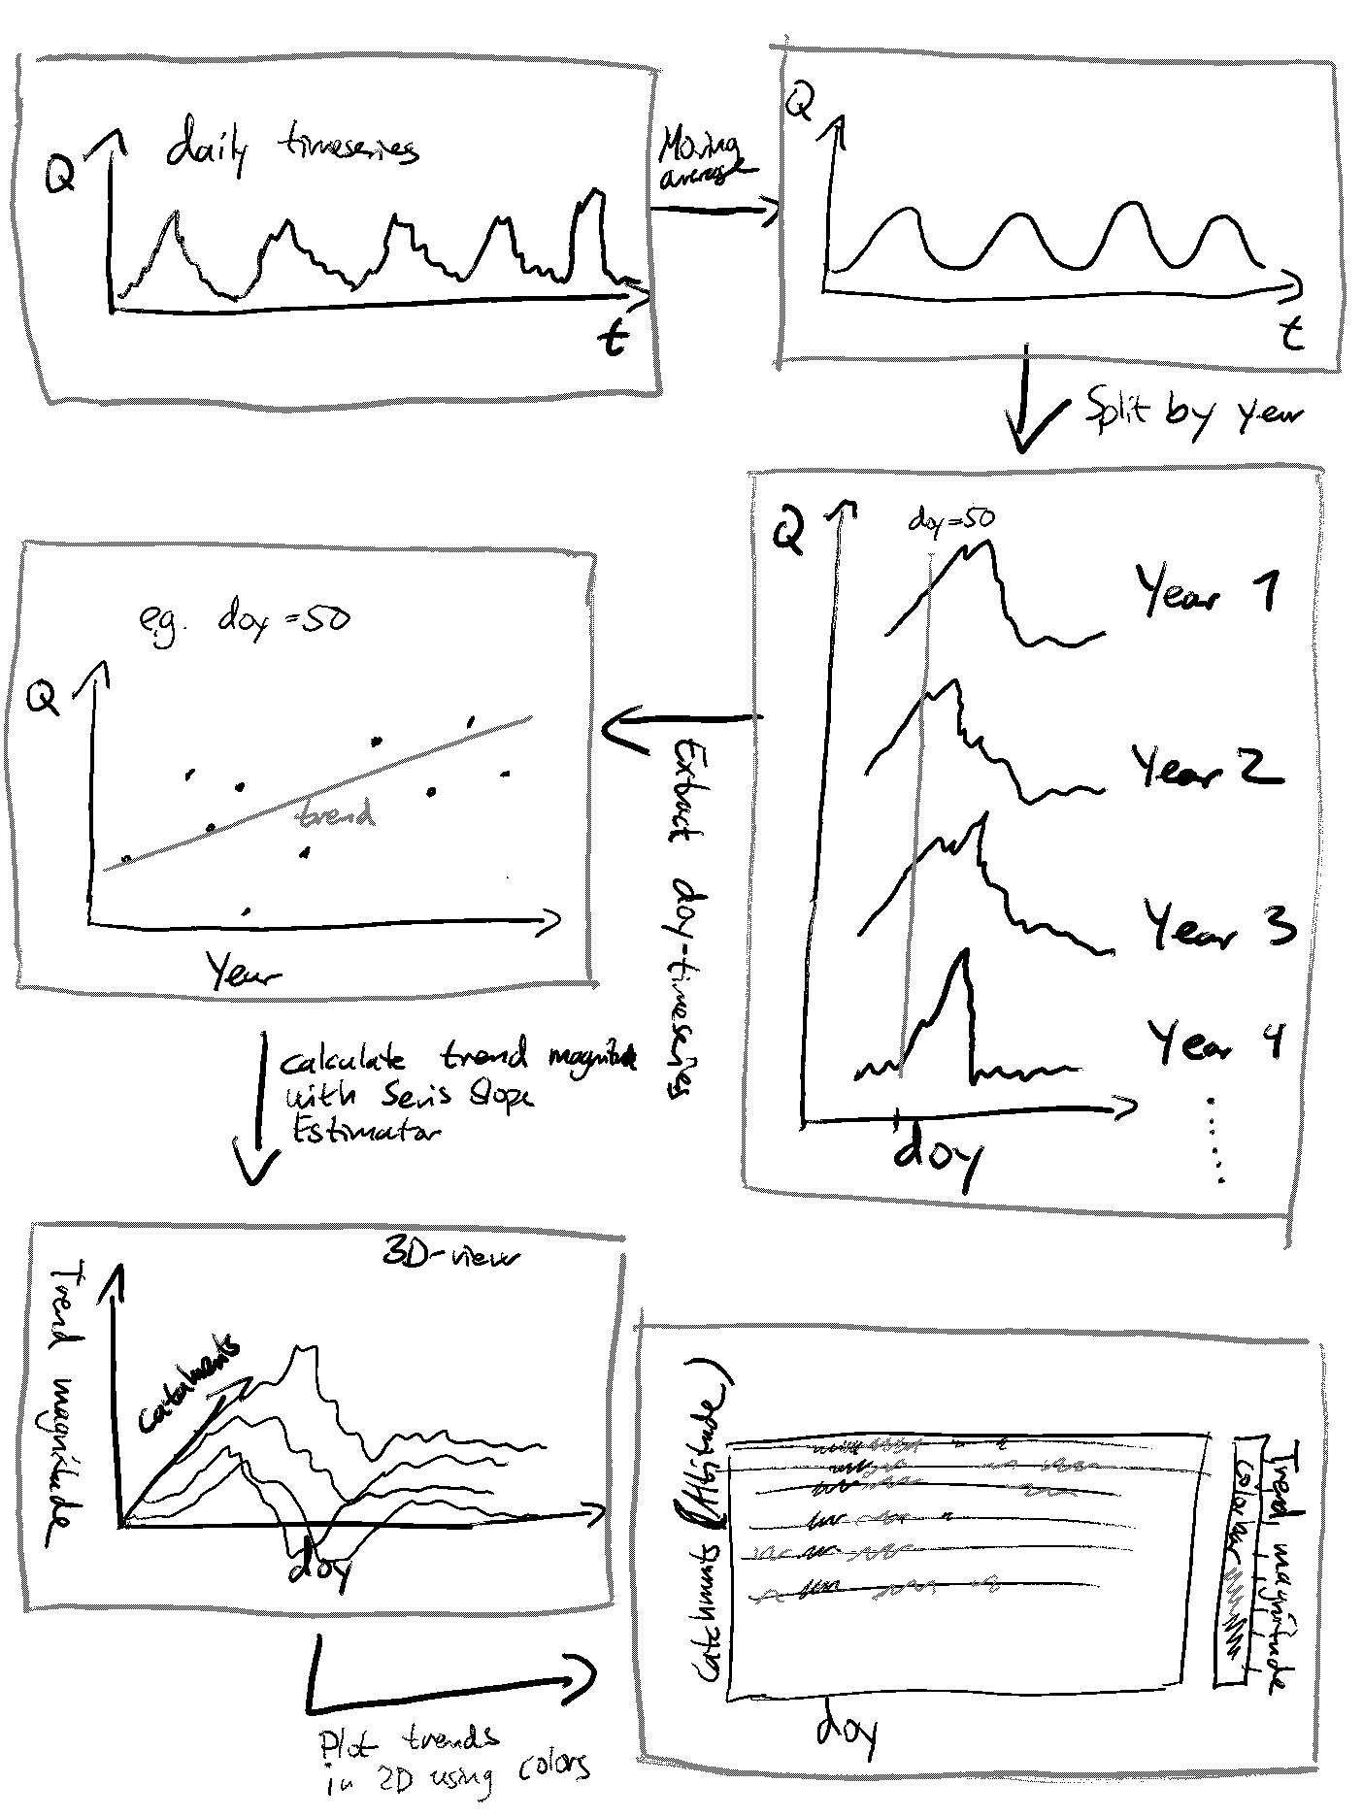
Figure 2: Flow chart explaining method

Assumptions and uncertainties related to the method
We acknowledge that since the MK test and SS estimator is designed to detect monotonic trends, abrupt change behaviour may not be accurately represented my out method. Nevertheless, the method has been proven to provide valuable insights into sub-seasonal trends.

Data-based attribution with multiple regression
To test our assumption that … we used ordinary least sqares multiple regression.
To what extent do the rainfall, snowmelt and temperature trends at a given DOY explain the streamflow trend at that same DOY.
(Eq. 4)

Results
(Summarise the findings of your research. State the facts, no speculation is allowed here. The results section follows the order of the figures.)
Temperature trends
A significant warming was found in …

Streamflow trends
The streamflow trends …
Two key findings in Østlandet:
- Increased streamflow in summer
- A positive-negative signal in spring (related to earlier snowmelt)
In comparison the streamflow trends in Vestlandet are less coherent, although the same positive-negative signal can be detected, in the latter half of the year there are a sucsession of positive and negative phases that appear not to be altitude dependent (these correspond clearly with rainfall trends).
Figure 3: Streamflow trends
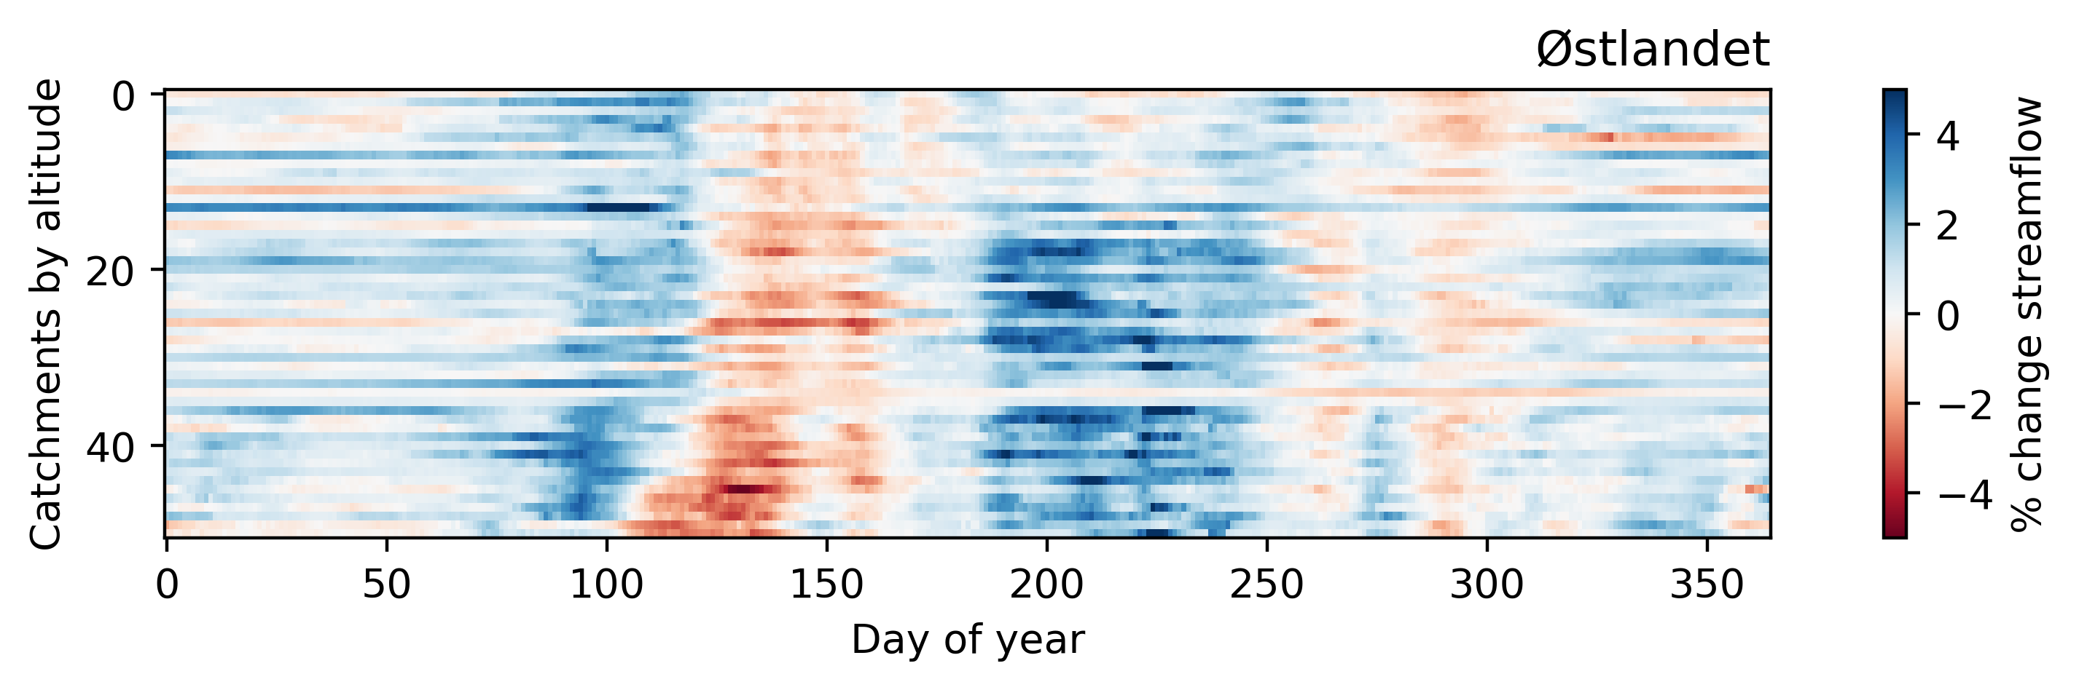
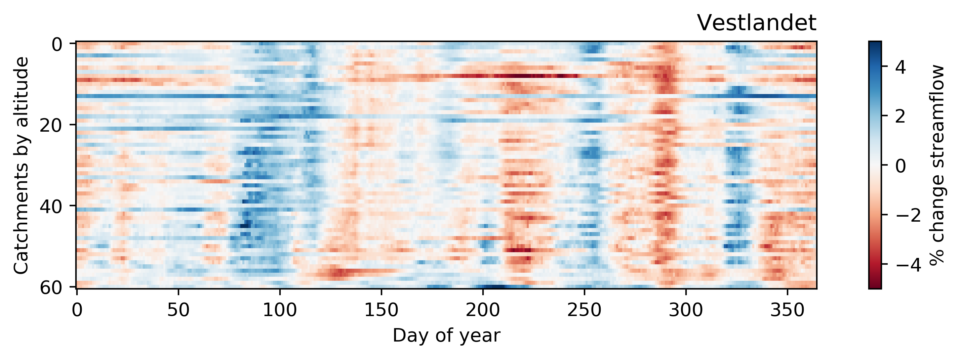

Snowmelt trends
The snowmelt trends show a clear and consistent shift to earlier onset of snowmelt across all catchments in both regions, except low-alititude catchments.
Figure 4: Snowmelt trend and snowmelt contributing proprotion trend
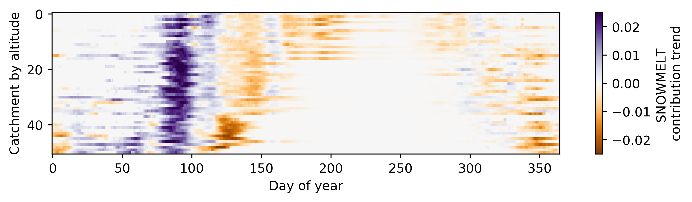
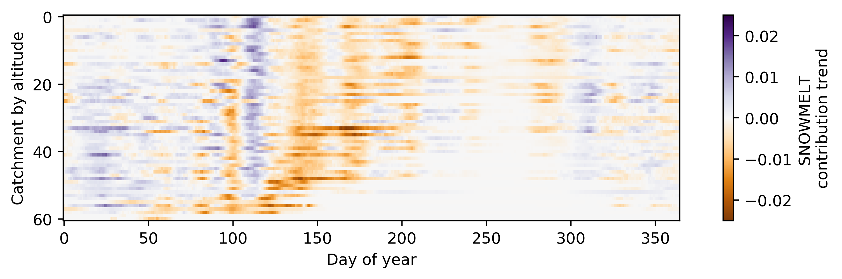
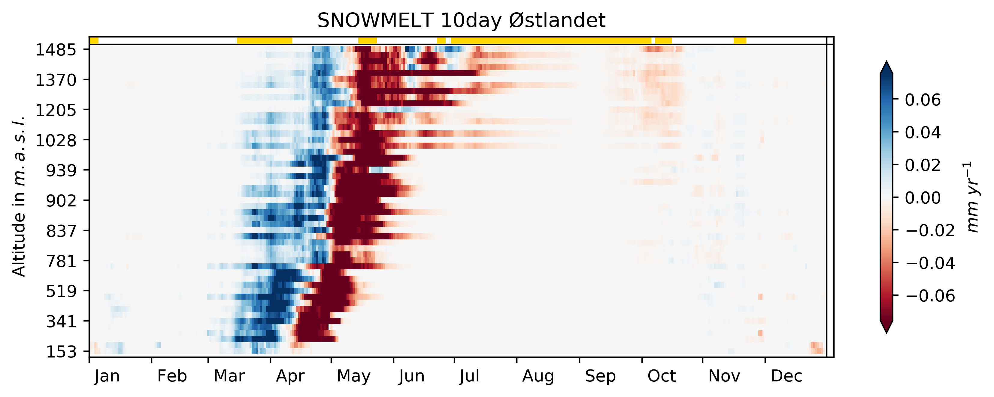
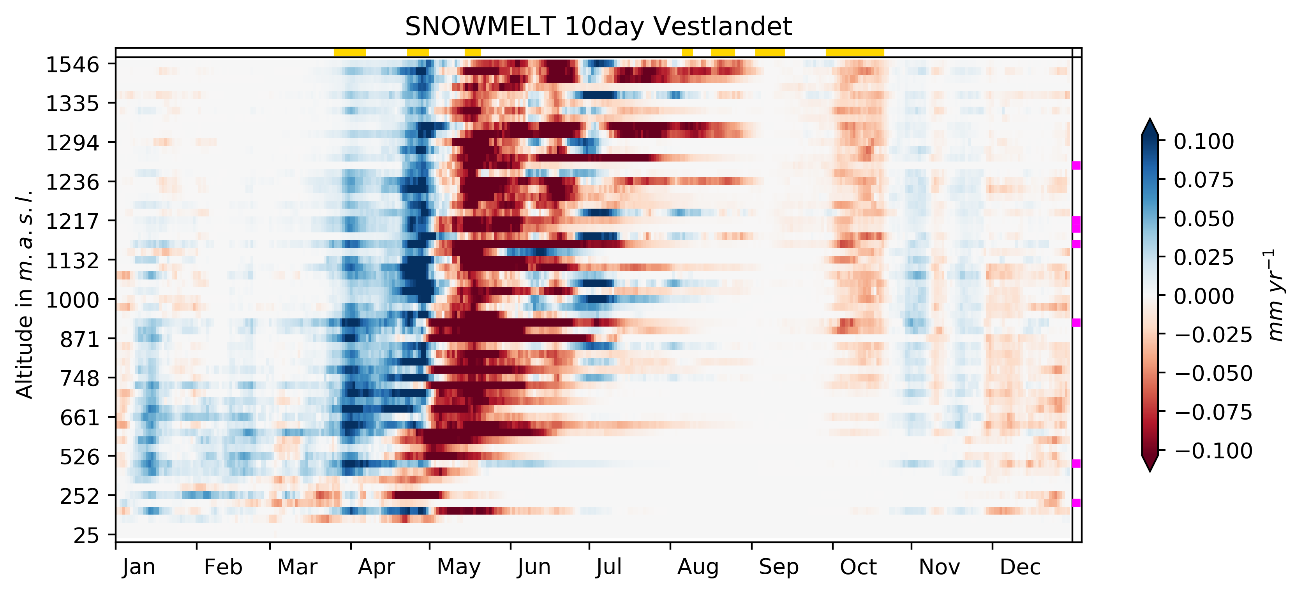

Rainfall trends
The rainfall trends
Figure 5: Rainfall trend and rainfall contibuting proportion trend
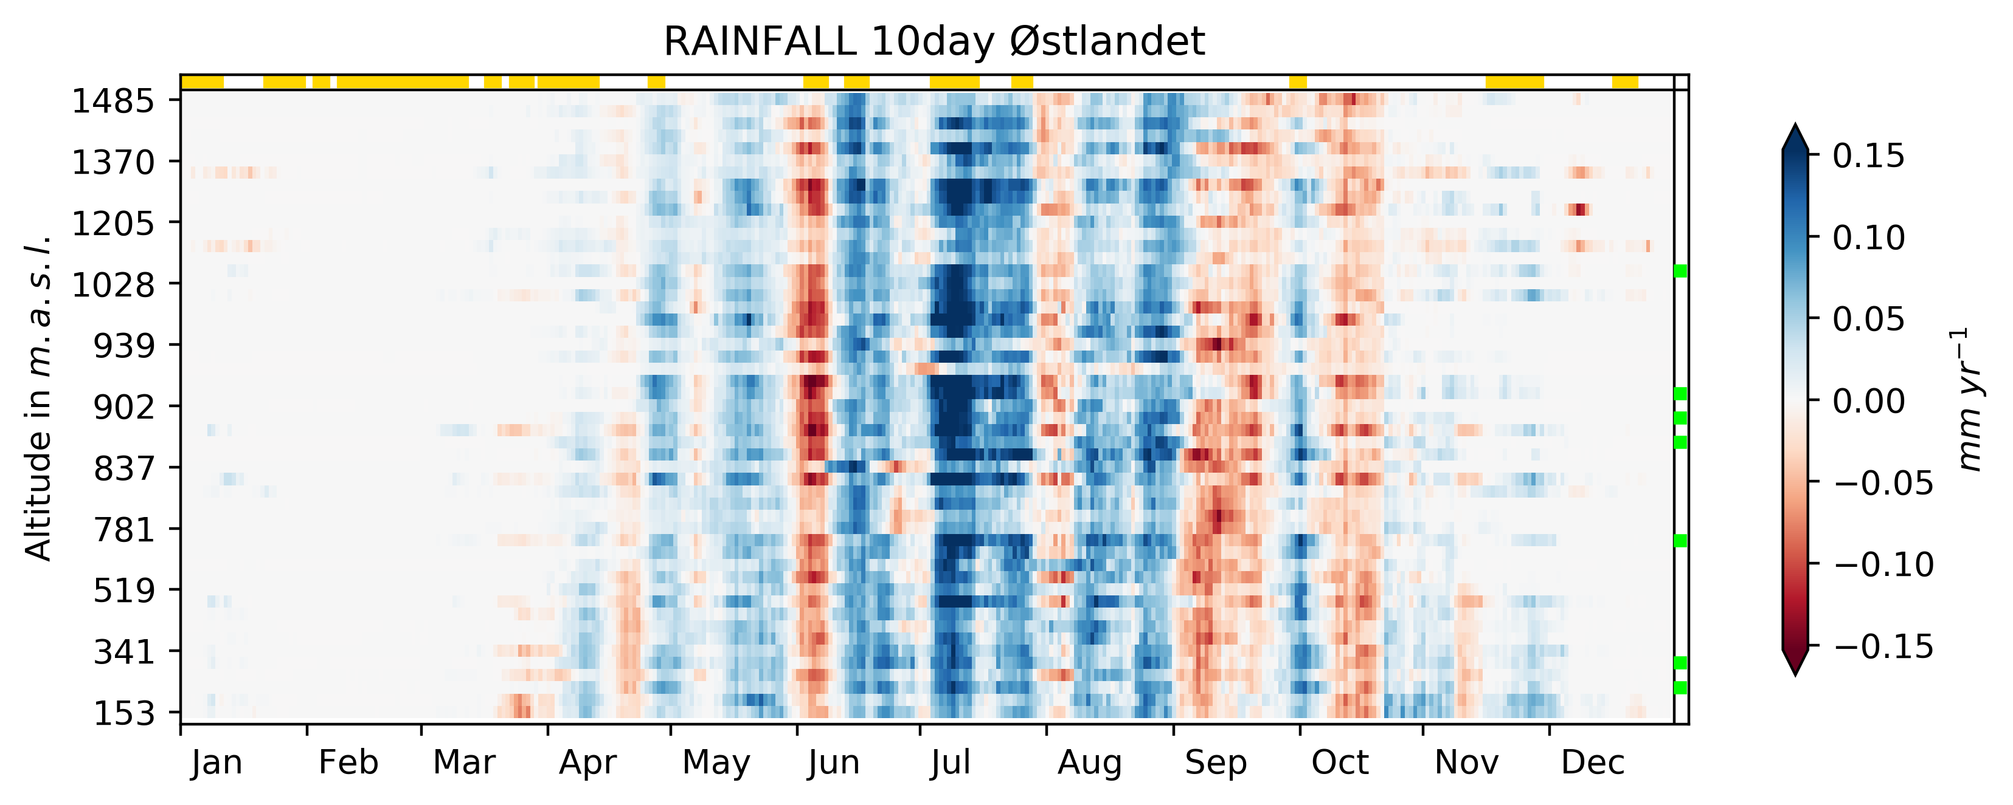
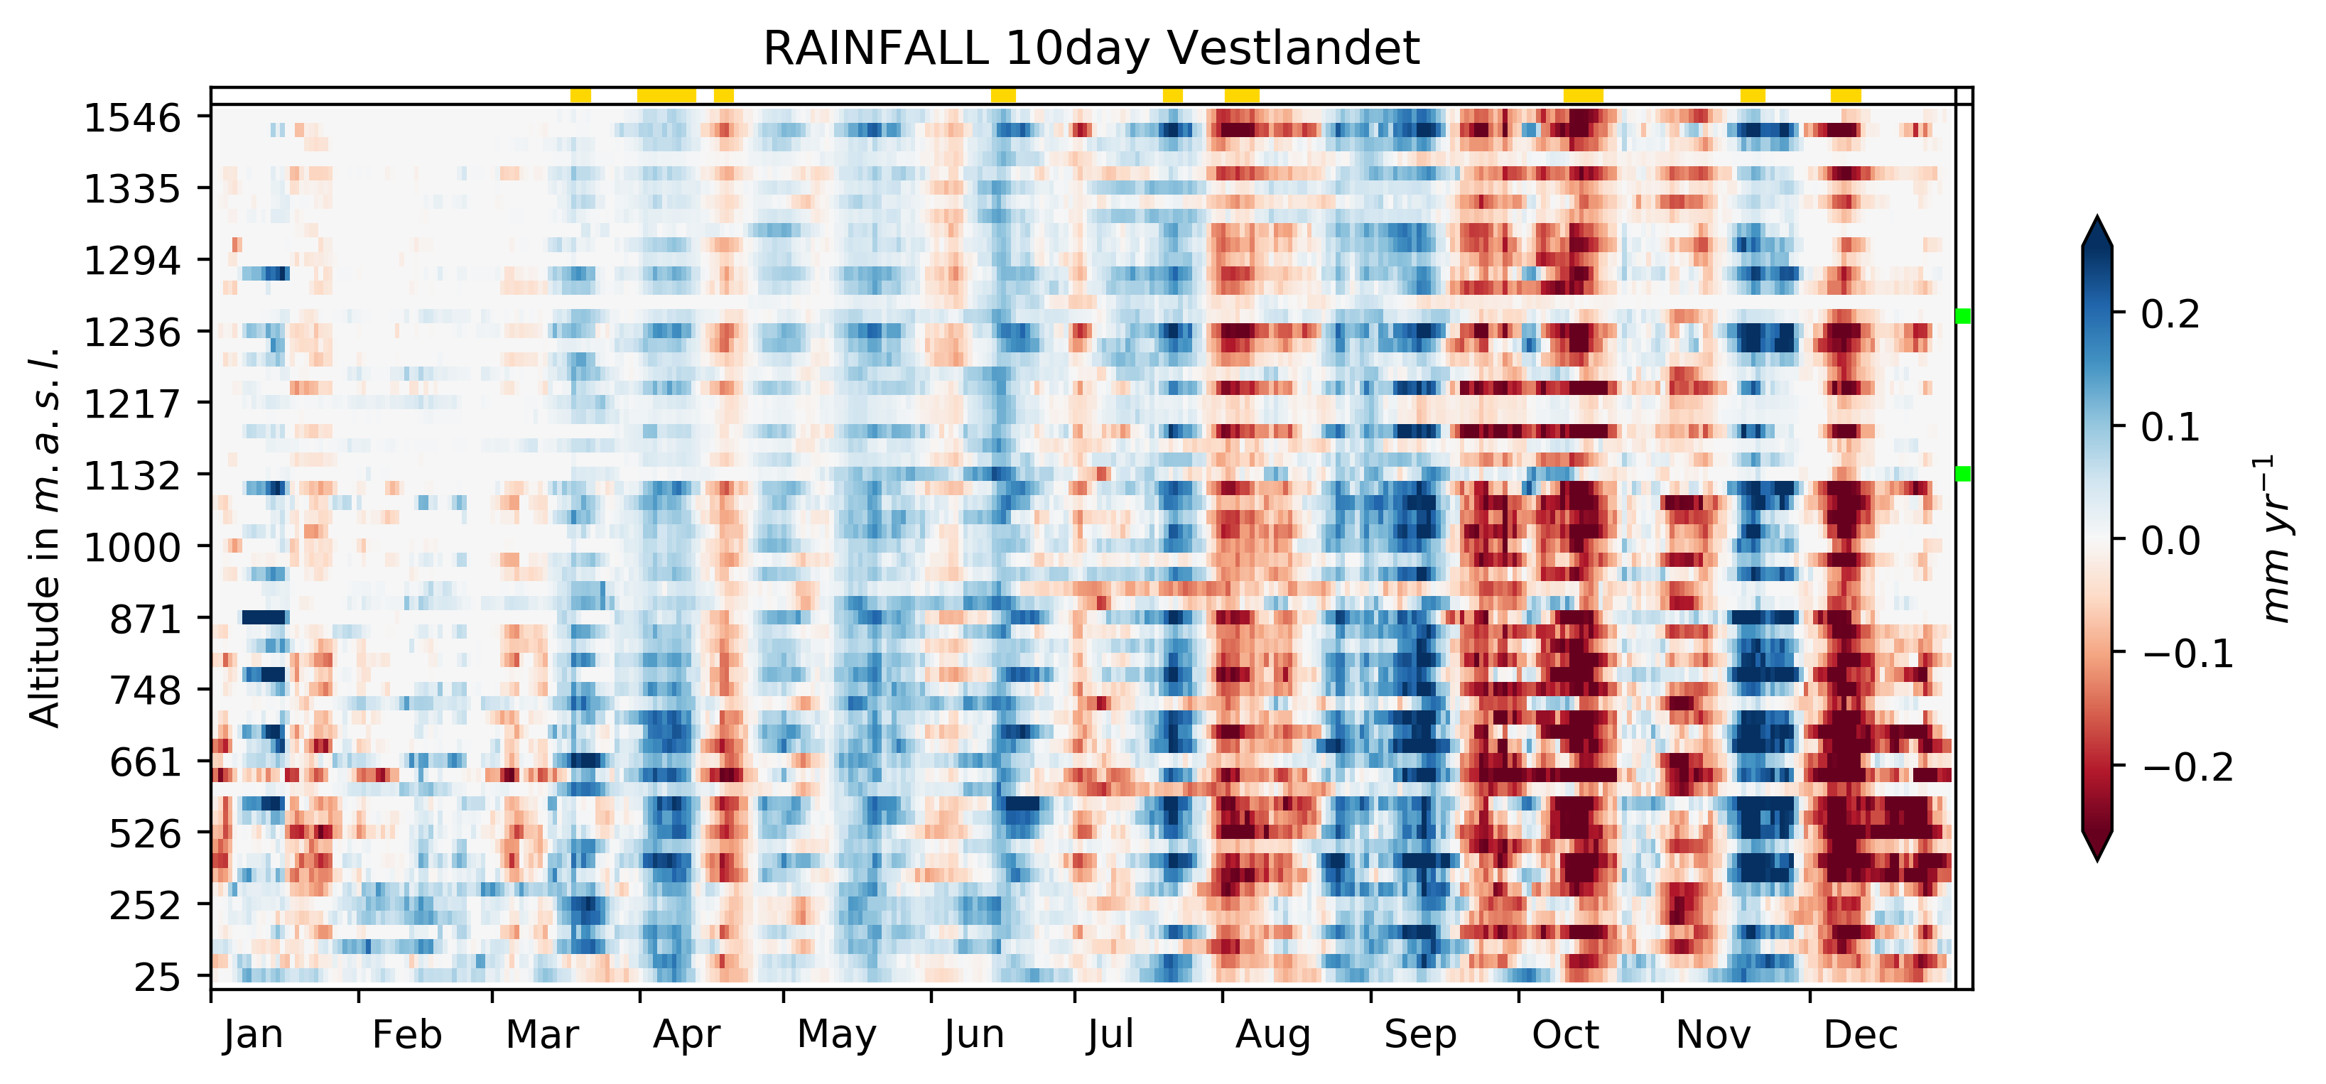
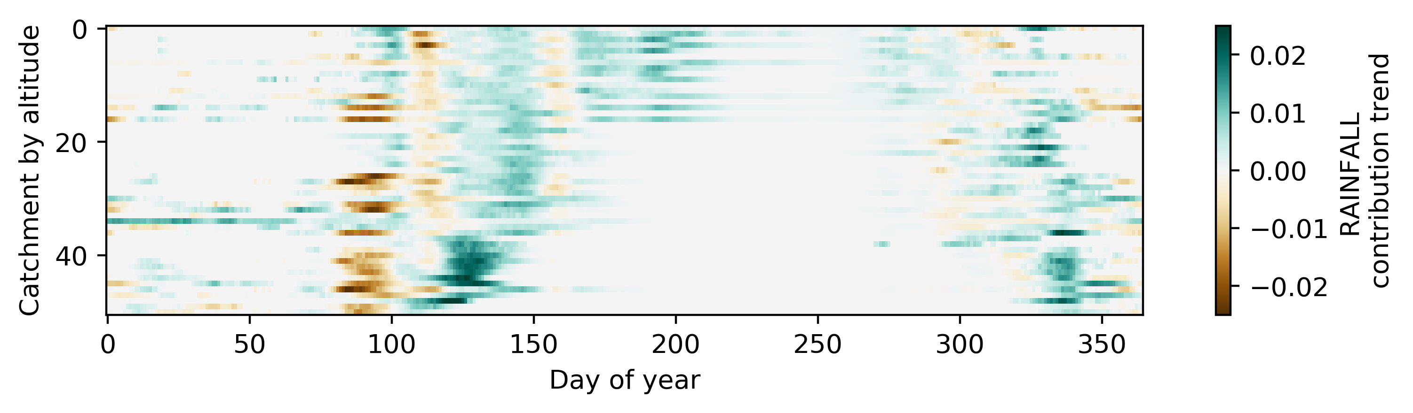
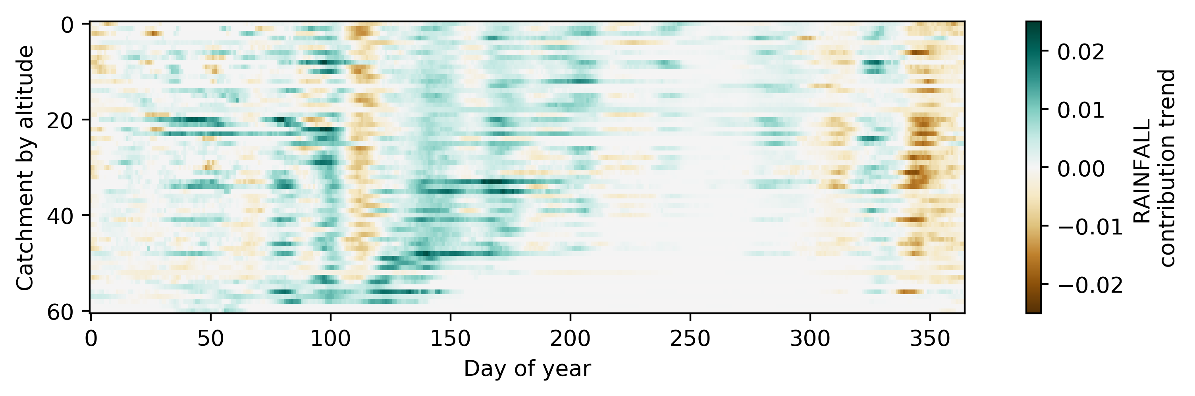
Figure 6: “Attribution” with multiple regression
Adding the temperature trends improved the regression ...
Attempts at creating an empirical model were unsuccessful, even when including independent variables to represent glacial melt, catchment gradient, etc.

Discussion
(Interperet findings in light of literature. Connect findings to each other. Connection between findings and excicsting literature. Results consistent with literature, why (not)? Organised by science question/THM)
Compared with previous studies using same method
Compared with Kormann et al.’s study in the Alps, which focused much on the influence of snow and glacial melt on streamflow, we have demonstrated the method on catchments that are more influenced by rainfall.
Evapotransiration
Findings suggest that streamflow during summer has increased in Østlandet from 1983-2012, caused by increasing precipitation/rainfall. However, in recent years Østlandet has experienced severe summer droughts, indicating that evapotranspiration trends could be playing an increasingly important role in modifying the hydrological regime.
Quatifying the effects of evaportranspriation, especially with future warming in mind, should be a focus of future research.
The temperature trend “problem”
The temperature trend is thought to be a proxy for evapotranspiration, meaning a positive temperature trend indicates a negative streamflow trend. However, in catchments with glaciation, a positive temperature trend could result in a positive streamflow trend due to increased glacial melt.
Influence of atmospheric circulation, weather patterns and climate variability
Changes in paths of low-pressure systems from the Atlantic
NAO known to be influencial in seasonal snowpack
These effects could be masking any trends seen due to global warming, but also these effects (and climate variability) are in turn affected by climate change.
Rottler et al. (2019)⁠ argued that “changing frequencies of weather types have to be taken into account when discussing yearly cycles of trend magnitudes of climatic variables”.
Uncertainties
seNorge data based on meteorological station measurements that are interpolated, high altitude areas are underrepresented see Figure 1 (Lussana et al., 2018)⁠
Future trends?
This paper discusses observed hydrological trends, but what about the future? Climate change will lead to higher temperatures, higher precipitation(?), and less snow accumulation(?). As snow is (mainly) governed by both precipitation and temperature, it may respond differently to future climate change than what has been observed. E.g. the observed longer snowmelt period in higher lying catchments, may be different if warming reaches a point where snowpack trends are only negative.
Additionally, any changes in prevailing weather patterns may have a much stronger influence than a mean warming. (See Hanssen-Bauer)

Conclusion

References

Beldring, S., Engen-Skaugen, T., Førland, E. J., & Roald, L. A. (2008). Climate change impacts on hydrological processes in Norway based on two methods for transferring regional climate model results to meteorological station sites. Tellus, Series A: Dynamic Meteorology and Oceanography, 60 A(3), 439–450. https://doi.org/10.1111/j.1600-0870.2008.00306.x
Beldring, S., Roald, L. A., Engen-Skaugen, T., & Førland, E. J. (2006). Climate Change Impacts on Hydrological Processes in Norway 2071-2100.
Blöschl, G., Bierkens, M. F. P., Chambel, A., Cudennec, C., Destouni, G., Fiori, A., … Zhang, Y. (2019). Twenty-three unsolved problems in hydrology (UPH)–a community perspective. Hydrological Sciences Journal, 64(10), 1141–1158. https://doi.org/10.1080/02626667.2019.1620507
Burn, D. H., Hannaford, J., Hodgkins, G. A., Whitfield, P. H., Thorne, R., & Marsh, T. (2012). Reference hydrologic networks II. Using reference hydrologic networks to assess climate-driven changes in streamflow. Hydrological Sciences Journal, 57(8), 1580–1593. https://doi.org/10.1080/02626667.2012.728705
Chandler, R. E., & Scott, E. M. (2011). Statistical Methods for Trend Detection and Analysis in the Environmental Sciences. In Statistical Methods for Trend Detection and Analysis in the Environmental Sciences. https://doi.org/10.1002/9781119991571
Déry, S. J., Stahl, K., Moore, R. D., Whitfield, P. H., Menounos, B., & Burford, J. E. (2009). Detection of runoff timing changes in pluvial, nival, and glacial rivers of western Canada. Water Resources Research, 45(4), 1–11. https://doi.org/10.1029/2008WR006975
Engeset, R. V. (2016). Hvordan lages vær- og snødata på seNorge.no og XGEO.no? (pp. 1–5). pp. 1–5. Retrieved from https://www.nve.no/Media/4813/weatherandsnowdata_v2_no.pdf
Fleig, A. K., Andreassen, L. M., Barfod, E., Haga, J., Haugen, L. E., Hisdal, H., … Saloranta, T. (2013). Norwegian Hydrological Reference Dataset for Climate Change Studies (A. K. Fleig, Ed.). Retrieved from http://webby.nve.no/publikasjoner/rapport/2013/rapport2013_02.pdf
Gottschalk, L., Jensen, J. L., Lundquist, D., Solantie, R., & Tollan, A. (1979). Hydrologic regions in the Nordic countries. Nordic Hydrology, 10(5), 273–286. https://doi.org/10.2166/nh.1979.0010
Hanssen-Bauer, I., Førland, E. J., Haddeland, I., Hisdal, H., Mayer, S., Nesje, A., … Ådlandsvik, B. (2015). Klima i Norge 2100: Kunnskapsgrunnlag for klimatilpasning oppdatert i 2015.
Helsel, D. R., & Hirsch, R. M. (1992). Statistical methods in water resources. Statistical Methods in Water Resources. https://doi.org/10.2307/1269385
Hisdal, H., Stahl, K., Tallaksen, L. M., & Demuth, S. (2001). Have streamflow droughts in Europe become more severe or frequent? International Journal of Climatology, 21(3), 317–333. https://doi.org/10.1002/joc.619
Kendall, M. G. (1975). Rank correlation measures. Charles Griffin, London, 202, 15.
Kim, J. S., & Jain, S. (2010). High-resolution streamflow trend analysis applicable to annual decision calendars: A western United States case study. Climatic Change, 102(3), 699–707. https://doi.org/10.1007/s10584-010-9933-3
Kormann, C., Francke, T., & Bronstert, A. (2014). Detection of regional climate change effects on alpine hydrology by daily resolution trend analysis in Tyrol, Austria. Journal of Water and Climate Change, 6(1), 124–143. https://doi.org/10.2166/wcc.2014.099
Kormann, C., Francke, T., Renner, M., & Bronstert, A. (2015). Attribution of high resolution streamflow trends in Western Austria - an approach based on climate and discharge station data. Hydrology and Earth System Sciences, 19(3), 1225–1245. https://doi.org/10.5194/hess-19-1225-2015
Kormann, Christoph, Bronstert, A., Francke, T., Recknagel, T., & Graeff, T. (2016). Model-Based Attribution of High-Resolution Streamflow Trends in Two Alpine Basins of Western Austria. Hydrology, 3(1), 7. https://doi.org/10.3390/hydrology3010007
Ljung, G. M., & Box, G. E. P. (1978). On a measure of lack of fit in time series models. Biometrika, 65(2), 297–303. https://doi.org/10.1093/biomet/65.2.297
Lussana, C., Saloranta, T., Skaugen, T., Magnusson, J., Einar Tveito, O., & Andersen, J. (2018). SeNorge2 daily precipitation, an observational gridded dataset over Norway from 1957 to the present day. Earth System Science Data, 10(1), 235–249. https://doi.org/10.5194/essd-10-235-2018
Mann, H. B. (1945). Nonparametric Tests Against Trend. Econometrica, 13(3), 245. https://doi.org/10.2307/1907187
Mohr, M., & Tveito, O. E. (2008). Daily temperature and precipitation maps with 1 km resolution derived from Norwegian weather observations. 17th Conf. on Applied Climatology, 6.3, 6.
Rottler, E., Kormann, C., Francke, T., & Bronstert, A. (2019). Elevation-dependent warming in the Swiss Alps 1981–2017: Features, forcings and feedbacks. International Journal of Climatology, 39(5), 2556–2568. https://doi.org/10.1002/joc.5970
Saloranta, T. M. (2014). Simulating more accurate snow maps for Norway with MCMC parameter estimation method. The Cryosphere Discussions, 8(2), 1973–2003. https://doi.org/10.5194/tcd-8-1973-2014
Sen, P. K. (1968). Estimates of the Regression Coefficient Based on Kendall’s Tau. Journal of the American Statistical Association, 63(324), 1379–1389. https://doi.org/10.1080/01621459.1968.10480934
Skålevåg, A. (2019). Hydrological trends in a warming climate: A daily trend analysis of 207 Norwegian catchments (Unpublished MSc Dissertation). Department of Geography, University College London, London, UK.
Stahl, K., Hisdal, H., Hannaford, J., Tallaksen, L. M., Van Lanen, H. A. J., Sauquet, E., … J́odar, J. (2010). Streamflow trends in Europe: Evidence from a dataset of near-natural catchments. Hydrology and Earth System Sciences, 14(12), 2367–2382. https://doi.org/10.5194/hess-14-2367-2010
Theil, H. (1950). A rank-invariant method of linear and polynomial regression analysis. Nederl. Akad. Wetensch., Proc., 53, 386–392.
Vormoor, K., Lawrence, D., Schlichting, L., Wilson, D., & Wong, W. K. (2016). Evidence for changes in the magnitude and frequency of observed rainfall vs. snowmelt driven floods in Norway. Journal of Hydrology, 538, 33–48. https://doi.org/10.1016/j.jhydrol.2016.03.066
Wang, X. L., & Swail, V. R. (2001). Changes of Extreme Wave Heights in Northern Hemisphere Oceans and Related Atmospheric Circulation Regimes. Journal of Climate, 14(10), 2204–2221. https://doi.org/10.1175/1520-0442(2001)014<2204:COEWHI>2.0.CO;2
Whitfield, P. H., Burn, D. H., Hannaford, J., Higgins, H., Hodgkins, G. A., Marsh, T., & Looser, U. (2012). Reference hydrologic networks I. The status and potential future directions of national reference hydrologic networks for detecting trends. Hydrological Sciences Journal, 57(8), 1562–1579. https://doi.org/10.1080/02626667.2012.728706

Tables
Each table complete with title and footnotes.
Tables should be self-contained and complement, not duplicate, information contained in the text. They should be supplied as editable files, not pasted as images. Legends should be concise but comprehensive – the table, legend, and footnotes must be understandable without reference to the text. All abbreviations must be defined in footnotes. Footnote symbols: †, ‡, §, ¶, should be used (in that order) and *, **, *** should be reserved for P-values. Statistical measures such as SD or SEM should be identified in the headings.

Figure legends
Legends should be concise but comprehensive – the figure and its legend must be understandable without reference to the text. Include definitions of any symbols used and define/explain all abbreviations and units of measurement.

Supplementary material

Methods
The MK test statistic S is given by
(Eq. 1)
where X_{j} and X_{i} are sequential values in the time series with length n, which the time series is applied to, and
(Eq. 2)

